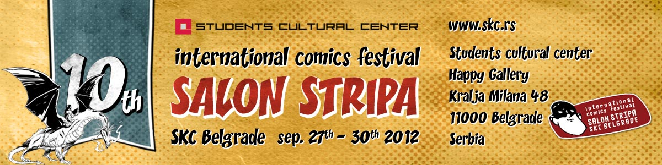

APPLICATION FORM FOR

10th INTERNATIONAL COMICS FESTIVAL CONTEST 2012

Deadline: |  |  |  | August 20, 2012
Sending address: |  |  |  | SKC Happy Gallery  SALON STRIPA  Kralja Milana 48  11000 Belgrade, SERBIA
Date of the Festival: |  |  |  | September 27 – 30, 2012
No. / Category / Decision of jury (to be filled in by jury)

 |  |  |  | above 15 years of age  15 years of age or below |  | exhibition out of exhibition  award
About the comic (to be filled in by applicant)

Title: |  |  |  |  |  |  |  | Number of pages:
About the author / authors (to be filled in by applicant)

Name and Surname: |  |  | Writer |  | Artist |  |  |  | Colorist
Date of Birth: (Day, Month and Year)

Address:
(Street, City and Country)
Contact |  | Tel: Mobile: E-mail:
Citizenship:
Sender (one of the authors) (to be filled in by applicant)

Name and Surname: |  |  |  |  |  |  | Signature:

